St. Columbkille News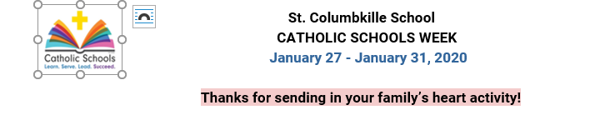

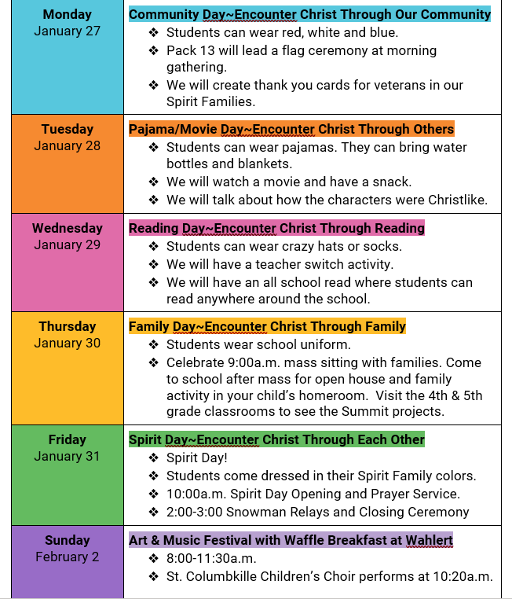

January 24, 2020

Greetings from Mrs. Roling:
Our annual celebration and recognition of the value, impact and contribution of Catholic Schools begins next week! This is a week where we highlight the uniqueness of our school. Our service project on Monday places our faith in action and teaches our value of being Christ to others and love of our country. The crazy apparel of Tuesday and Wednesday shows our goal of making learning fun for our students. Our movie conversations focus on how we always work to integrate our faith and the 7 Habits into our daily lessons. Reading (and writing) are a huge emphasis at St. Columbkille--which is why we have a day promoting reading. Family is important to us, and all Catholic Schools, especially celebrating liturgy together. Academics and student growth are our mission which is displayed through our Open House following mass. Building community is another core value witnessed during Spirit Day. Our Spirit Families work together, dress in the same color and have lots of team fun. Then on Sunday you have the opportunity to experience a larger community that values the arts at our Art and Music Festival, and eating waffles! The week truly showcases who we are and the strong foundational core we build in your children. Thank you for your support and involvement--together we our changing our world for the better!
Our Catholic Schools Week committee planned a wonderful week! Pray for good weather and full days of school all week!
Please pray for Mrs. Jenni Malcom, our Technology Coach, and her family. Mrs. Malcom's father passed away suddenly late Wednesday afternoon. He is from Stockton, IL. Arrangements are being decided today. Eternal rest grant unto him O Lord. And let perpetual light shine upon him. May he rest in peace. Amen.
Blessings to you and your family,
Mrs. Barb Roling

Upcoming Events:
- January 27-31 Catholic Schools Week
- January 27 - 5th grade parent information night and activity night, 6:30-7:30pm
- January 30 - Family Mass at 9:00, followed by Open House in school
- January 31 - Spirit Day!
- February 2nd - Art and Music Festival with a Waffle Breakfast at Wahlert
- No School- February 7th- Professional Development
- February 14th-Out of Uniform
Looking Ahead
- Conferences- February 18- 20th
- No School- February 20th- 21st
- Parent Association Meeting, 5:30-6:30pm
- Spring Break- March 16- 20th
Check the calendar for full listing of events.

Mass Schedule:
Mass is every Thursday at 9:00 a.m. at St. Columbkille Church, unless otherwise stated.
- January 30th- Prepared by Catholic Schools Week Committee
- February 6th- prepared by Mrs. Weig's Class
- February 13th- prepared by Mrs. Burke's Class
- Wednesday, February 19th- prepared by Mrs. Johnson
- Wednesday,February, 26th- prepared by both 5th Grade classes
Get Ready for Eagles Give Day on Wednesday, Jan. 29!
Dig out your blue and gold and get ready for EAGLES GIVE DAY, Holy Family's 24-hour online giving event starting at noon on Wednesday, January 29, 2020.
Your gift on Eagles Give Day supports the Student Impact Fund which provides the unrestricted funds needed annually to support the day-to-day operations and most pressing needs of our students and schools – such as tuition assistance, technology upgrades, retreat opportunities, classroom resources, employee salaries, benefits and professional development, facilities maintenance, and so much more.
Take part in one of several challenges to help us reach our goal of $30,000 in 24-hours. With your help in reaching our goal, Holy Family will earn an extra $10,000 in challenge grants from our Eagles Give Day sponsors Sedona Staffing Services & StackStone Wealth.
>>Learn more and get in on the fun at holyfamilydbq.org/EaglesGive
SPELLING BEE
Our Spelling Bee was held this week, with 19 students competing in the written first round. 8 students competed in the second round, which is the oral spelling bee. Making it through 21 rounds is our local spelling champion Emma Decker! Congratulations to Emma who will represent St. Columbkille at the next level in the spring. Congrats to Nile Connely, our runner up. Special recognition and congratulations to Ben Freund, Lilly Eisbach, Jack Thomas, Aaliyah Smothers, Addison Ness and Ella Kennedy. They all showed wonderful poise and tenacity!
GEOGRAPHY BEE
We held our 15th annual Geography Bee last week! We had 14 determined 4th and 5th grade students compete for the school championship and the chance to qualify for the state competition. Congratulations to Finnegan Newlin, our first place champion! Our second place runner up was Luke Lundstrom. Third place went to James Richardson. The other contestants were: Mary Weires, Evan Klousia, Maren Pederson, Aaliyah Smothers, Elyse Cloos, Lydia Lundstrom, Brennan Rix, Jack Rothert, Brayden Tanny, Addison Ness and Eli Mulligan. Many hours were spent studying for this two day competition! Thank you to everyone who made this bee a success!
The tuition assistance application for next school year is now available at online.factsmgt.com/aid and the deadline to apply is April 15, 2020.
Tuition assistance help nights are scheduled for:
- Wednesday, February 26, from 5:30 to 7:00 p.m. and
- Thursday, March 26, from 4:30 to 6:00 p.m.
These sessions will take place in the Holy Family central office at 2005 Kane Street. An optional informational meeting will be held during the first half hour each night. If you plan to attend the informational meeting and/or need childcare for a session, please RSVP to Katie Tracy at ktracy@holyfamilydbq.org.
St. Columbkille Early Childhood is seeking a caring, nurturing, energetic and dependable early childhood associate to work part-time. We offer a competitive starting wage of $10.00 per hour.The following 9-month positions are currently available:
- Part-time associate
  - Monday - Friday, afternoon shift
- Part-time associate
  - Monday - Friday, 11:00 a.m.-1:00 p.m.
Our associates plan and carry out daily activities, which include supervising children, preparing materials and supplies, setting up learning centers and helping with general housekeeping tasks. Early childhood experience is preferred. Training will be provided for the right candidate.
Interested candidates should click on "Apply Today" to complete a Holy Family application and submit a resume. Any questions regarding this position should be directed to Marcy Weidenbacher, Early Childhood Director, at mweidenbacher@holyfamilydbq.org or 563-583-1620.

