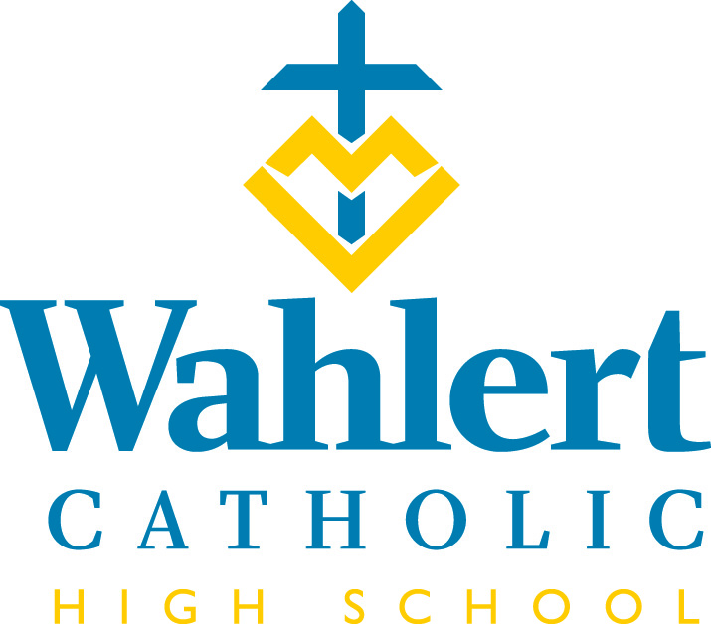
Fly-By for Jan. 12 – Jan. 26, 2018
This weekly FLY-BY strives to communicate the events and news of Wahlert Catholic in a somewhat timely manner.

Happy New Year! We know it’s been a while since the last Fly-by, but we’ve been busy ending the semester, throwing Kairos retreats, and just surviving the freezing cold. Here are some of the things that have happened since the last newsletter:

The Wahlert Dance Team took 3rd place in Jazz and 4th place in Lyrical at the Dance Team State Competition.

Campus ministry and several senior leaders successfully ran two Kairos retreats for juniors within a three week time period. K-12 was Dec. 15-18 and K-13 was Jan. 5-8. Thanks to all of those who supported the retreatants in any way.

From the Teacher Appreciation Committee: Thank you to Lisa Graf of Inside Decor Rental for her generous donation of all the platters, wrap and decorations and for her talent of wrapping the cookie trays for all of the Wahlert/Holy Family staff so beautifully. Thank you to all the parents who baked goodies, helped wrap and decorate trays or donated money. This wonderful experience would not have been possible without you!"

The Knitting Club will be donating around a total of 125 items --baby blankets and hats to the Clarity Clinic on Hillcrest as well as kids' hats, scarves and headbands to Lincoln Elementary and Fulton Elementary as well as adult hats and scarves to The United Way for homeless people in the area. Even though the club is smaller this year--around 20 or so, we keep increasing in productivity. A special thanks to Becky Varley and Patty Green for making numerous items. Our club is open to all students, beginning to advanced knitters, and it meets Wednesdays and Thursdays from 3 to 4:30 p.m.

IN THE WEEK AHEAD…
Next week’s schedule will be: O-E-O-E. Monday, Jan. 15, students will NOT have classes. It is an in-service day for teachers.

The week of Jan. 22-26, the schedule will be: O-E-O-E-O

Friday, Jan. 12: End of first semester.
Saturday, Jan. 13: Show Choir Home Show at 2 and 7 p.m.
Sunday, Jan. 14: Interact Club Basketball tournament and Dance Marathon from xx
Monday, Jan. 15: No school. Teacher in-service.
Tuesday, Jan. 16: Second semester begins.
Friday, Jan. 19: Show Choir and Jazz Band Show performed for 4th to 8th grade students
Jan. 19 to Jan. 21: Two Days of Theatre
Wahlert Catholic High School’s ninth- and 10th-grade drama students will present three student-directed performances Jan. 19-20, 2018, in the R.C. and Celeste Wahlert Theater on the ground floor of Wahlert Catholic. Tickets are $6 and can be purchased at WahlertCatholicArts.org. from Tuesday, Jan. 9 at 8 a.m. until 2 hours before the show on show days. Tickets are also available at the door 60 minutes before curtain. Doors open 30 minutes before curtain.

Performances are scheduled for:
Friday, Jan. 19, at 7:30 p.m.
Saturday, Jan. 20, at 1 p.m. and at 7:30 p.m.
​
Each performance will feature the following three productions:
- Appropriate Audience Behavior by Ian McWethy
Directed by: Gwyneth McSperrin and Owen Borelli, Wahlert Catholic students
- Boise, Idaho by Sean Michael Welch
Directed by: Eric Leigh and Sophia Shubatt
- All I Really Need to Know I Learned by Being in a Bad Play by Werner Trieschmann
Directed by: Jennifer Carpenter and Abby Burns

Saturday, Jan. 27: Bellevue Marquette TEC
Jan. 27: Science Quiz Bowl Competition. Good luck to Sophia Shubatt, Joe Patrick, Ann Hermann, Jayne Munshower and Gabe Wigginton as they compete in the Iowa Regional High School Science Bowl.

Jan. 27: Show Choir Competition at Anamosa
OTHER THINGS YOU MAY WANT TO KNOW…
BLOOD DRIVE COMING
A blood drive will be held at Wahlert Catholic on Tuesday, Feb. 13 from 8:30 a.m. – 12:30 p.m. All 16, 17, 18, and 19 year olds may give blood if they present a signed permission slip. The due date for the permission slip is Wednesday, Feb. 7. Please encourage your son/daughter to give blood.
Parents are also encouraged to give blood on this day. As a parent, if you are interested in giving blood, please email Ms. Wagner (cwagner@holyfamilydbq.org) the requested time for donation.
If you have questions, please email or call Ms. Wagner.
ROCK THE RAFTERS.
The Wahlert Dance Team is sponsoring a dance camp for children ages 4 to 12. The camp, at which participants will learn a dance to be showcased later in the day, runs from 12 to 2:30 p.m. Cost is $25 per participant. Contact Amanda Collins at acollins@holyfamily.dbq.pvt.k12.ia.us for more information. Here is a link to the flyer outlining the activity: https://www.holyfamilydbq.org/document.doc?id=2187

DREAMING OF SPAIN
Our Spain trip this year is from June 8-20. We have 25 paying participants --21 students and 4 adults (parents of students) -- as well as three paid-for chaperones: Trini Olivera, her husband Jose Garcia, and an uncle of Timmy and Tori Salgado -- Bill Barrick. He was an adult participant on our last trip in 2016. Even though Mrs. Leonard will not be going on the trip this year, she is still doing all the planning and organizing since this is Trini and Jose's first trip with students. They will be leading the trip and we've decided this year to be our own group since we have a total of 28. Jose and Trini will be staying in their home country of Spain after the trip is over. In fact, one of the cities they will visit on the tour is their city of residence there --Granada. They'll be bringing their children along and their grandparents will be watching them while Trini and Jose are on the trip with our students.

TUTORING AVAILABLE
Does your student need tutoring in math, science or other areas? This link takes you to information about a tutor available in Dubuque: https://www.holyfamilydbq.org/ebulletin-board

THANK YOU to all those who helped me find my camera bag. It is now back where it belongs!

WINTER CARNIVAL VOLUNTEERS NEEDED
Resurrection School will host their annual Winter Carnival on Friday, Jan. 19 from 6 to 8 p.m. They are looking for volunteers. Please visit the following link to sign up. Thank you! http://www.signupgenius.com/go/60B0F4FADA828A5FB6-resurrection

HOLY FAMILY ART AND WAFFLES BREAKFAST – SUNDAY, FEB. 4 from 8 – 11:30 a.m.
Join us in the Wahlert Catholic Kehl Family Commons for freshly-made waffles and sausages, served up by Albrecht Acres from 8 to 11:30 a.m. Breakfast proceeds benefit Circle of Celebration and Albrecht Acres. Adult tickets are $8, children 6-12 are $6, and children under 5 eat free. While you eat, enjoy featured student artwork and choral performances from students throughout the system.

From the Holy Family Offices…
#EAGLESGIVE DAY IS JANUARY 30
Get ready to have some fun on social media and show your school pride on #EaglesGive day! In just over two weeks, we will once again take to social media for 24-hours to celebrate all that makes Holy Family special. Get involved by sharing a photo that shows your school pride, giving a teacher “shout out,” (don’t forget to use #EaglesGive!) and of course, consider making a gift. Through challenge grants, money match hours, and other fun contests, there will be lots of ways you can make an impact, and help make #EaglesGive day our biggest one-day social media fundraising event yet! More information can be found at holyfamilydbq.org/EaglesGive.

GET READY FOR SOME “QUICK CASH”!
Exciting changes are taking place with the Holy Family Circle of Celebration raffle this year! The “Quick Cash” raffle will feature NINE individual drawings for more chances to win, guaranteed prize values, and the opportunity to win more than once. Tickets are now on sale! Every family has received five tickets to purchase or sell, and more will be available upon request. Stay up-to-date on raffle drawings, auction announcements and Circle of Celebration event details by indicating your attendance or interest on the Circle of Celebration Facebook event.

TUITION ASSISTANCE APPLICATION NOW OPEN
The tuition assistance application is now open. For more information, or to fill out an application, visit: https://holyfamilydbq.org/admissions/apply-for-tuition-assistance.

TUITION ASSISTANCE HELP NIGHTS
Two help nights are scheduled for families who would like help with the FACTS tuition assistance application. Help sessions will take place on Thursday, Feb. 8, from 4 to 5:30 p.m. and Tuesday, Feb. 20, from 6 to 7:30 p.m. (a Spanish-speaking volunteer will be available) in the Holy Family Catholic Schools Central Office at 2005 Kane St., Dubuque. If you need assistance and are unable to attend these sessions, please contact Katie Tracy, tuition coordinator, at 563-582-5456 or ktracy@holyfamilydbq.org to make an appointment. More information on FACTS tuition assistance can be found at holyfamilydbq.org.
For Holy Family Catholic Schools news and events, find us on Facebook, Twitter, or visit www.holyfamilydbq.org.

UPCOMING EVENTS
Jan. 29 - Feb. 4: Catholic Schools Week
Jan. 31: Catholic Schools Week mass @ 10:05
Feb. 1: Take Away Hunger food packaging by STOP
Feb. 2: No school. Teacher in-service
Feb. 2: Blue/Gold Party
Feb. 4: Waffle Breakfast
Feb. 5: Parent-Teacher Conferences from 4 to 7:45 p.m.
Feb. 7: Academic Awards Assembly
Feb. 7: Parent-Teacher Conferences from 4 to 7:45 p.m.
Feb. 8: 9th Grade Parent Information Night from 6-7 p.m. in Kehl Commons Center (cafeteria).
Feb. 11: Rock the Rafters.

Feb. 12: 9th Grade Course Selection Night from 6:30 to 8 p.m.
Feb. 13: Blood drive
Feb. 14: Ash Wednesday Mass at 10:05 a.m.
Feb. 15: Parent-Teacher Conferences from 11 a.m. to 1 p.m.
Feb. 16: No school
Feb. 16: Deadline for Senior Ads in the yearbook. You should receive information in the mail in the fourth week of January.
Feb. 17: 9th Grade Course Selection Day from 9 to 10:30 a.m.
For more information about these events, see the Wahlert Catholic website at http:// holyfamilydbq.org or contact the school at
(563) 583-9771.
This information was compiled by Sandy Gaul, publications’ adviser. Her email is
sgaul@holyfamilydbq.org

