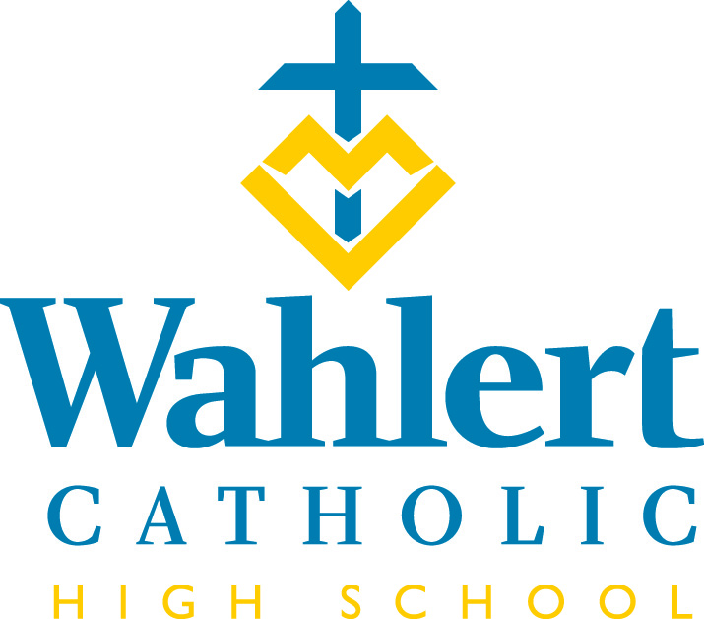
Fly-By for March 9 – March 30, 2018
This weekly FLY-BY strives to communicate the events and news of Wahlert Catholic in a somewhat timely manner.

Banner #64 is pretty special
Congratulations to the Wahlert Wrestling team, which won the program’s first ever state title dethroning returning state champion New Hampton. Wahlert only took four wrestlers to the tournament compared to New Hampton’s nine qualifiers. Wahlert won the tournament with 94 points compared to New Hampton’s 80.

All four of Wahlert’s wrestlers made it to the semifinals (a feat never done by a Wahlert team). Three of those four, Kolton Bartow, Josh Ramirez and Boone McDermott, semifinalist made it to the finals. Blake Bradley wrestled back to a fourth place finish. His win in the consolation semifinals won the Golden Eagles the tournament.

No program in Iowa history has ever won the Traditional State Tournament with just four wrestlers. This was done largely by the bonus points acquired by having Bartow, Ramirez, and McDermott pin their way to the finals.

McDermott and Ramirez won state titles with Bartow finishing second. McDermott ends his career as the winningest wrestler in program history.

Congratulations to junior Matthew Becker who received a 36 on his ACT. Earlier this year, Ann Hermann also received a 36 on the ACT.

Something pretty cool
Religion teacher Mr. Nathaniel Gee, or Brotha Gee as some refer to him, has had a documentary created about him. We thought you might enjoy watching it. Here’s the link: Brother - A Documentary

IN THE WEEK AHEAD…
Next week’s schedule will be: O-E-O-E-O.

The week of March 19-23, the schedule will be: E-O-E-O-E.
Please note that there is no school the week of March 26-30.
The week of April 2-6, the schedule will be: O-E-O-E-O (unless we have another snow day)

March 10: Winter Dance from 8:30 to 11 p.m. at Wahlert
March 12: Practice for women’s golf, men’s & women’s tennis and men’s soccer begins.
March 12: Freshman field trip to the Franciscan and Presentation mother houses to celebrate the work of sisters in the United States.
March 14: Grandparents’ mass
March 17: Booster Club Trivia Night (see information below)
March 18: Golden Finale for show choirs
March 19: First day of practice for women’s soccer.
March 19: ZAPPS – ACT prep course
March 20: ZAPPS
March 20: ICAN College and Career Planning. ICAN Financial Planning Night
March 21: Reconciliation
March 22: Reconciliation
March 26-30: No school. Spring break. Holy Week.
March 29: Deadline for Tuition Assistance applications
April 5-8: Kairos 14
April 7: Circle of Celebration
OTHER THINGS YOU MAY WANT TO KNOW…
SMARTS OR LUCK OF THE IRISH?
The Wahlert Catholic High School Booster Club is sponsoring a TRIVIA NIGHT Saturday, March 17 at the Joliet Events Center (Knights of Columbus Hall), 780 Locust St. Admission is $20 at the door. Pre-registration of team rosters (6 to 10 members) is available at ccorken744@gmail.com. Walk-ins welcome to join any team that night. Menu and bar available all night. Doors open at 6 p.m. Program is from 7 to 10 p.m. Proceeds support all Wahlert co-curricular programs. For more information, please contact Dan Corken (563-581-7143).

PLANNING FOR COLLEGE?
The Iowa College Access Network's (ICAN) College Planning and Financial Aid presentation is scheduled for Tuesday March 20, from 6 to 8 p.m. in the Wahlert cafeteria.

Topics to be covered include
- The College Search and Application Process
- Financial Aid Process
- FAFSA Application Review
- Understanding FAFSA Results
- Understanding Costs – College Comparisons
- Financial Aid Options
- Scholarships Process
- Where to Go for Help

ATTENTION PARENTS OF THE JUNIOR CLASS:
Looking for some last-minute ACT prep before the April ACT exam? Jason Derby, who has been running an ACT boot camp out of Cuba City High School, is willing to tutor current Wahlert juniors before the April ACT for free. If interested, please contact Jason at: 01jason20@gmail.com

A BIT OF SPAIN – RIGHT IN YOUR OWN HOME!
Wahlert Catholic High School will be hosting several high school students from Córdoba, Spain, from April 21 to April 29. We are looking for host families for these students. Are you interested in making a new friend? The Spanish students have studied English and will be attending classes at Wahlert during the week. This will be their first trip to the United States, and they are very excited to experience our culture. They will be travelling with teachers from their home school and are looking forward to practicing their English skills!
As a host, your main responsibility would be to provide room and board for the Spanish student. Transportation to school and any group activities could be arranged if necessary. If you are interested in this opportunity, please contact Becky Varley at bvarley@holyfamilydbq.org

ACT PREP TIME
The Doorway to College Foundation is providing a two-night ACT prep course for students at Wahlert. During the 5-hour class, students will learn tips on taking the exam, practice strategies, receive test prep material to work on at home, as well as partake in and review practice ACT exams in class. Classes will be held at Wahlert on Monday, March 19, and Tuesday, March 20, from 6:30 to 9 p.m. The cost for the course is $89.99 (use promotional code doorway2college). To register or to get more information, please visit: http://www.doorwaytocollege.com/act-test-prep

ATTENTION PARENTS OF ADVANCED PLACEMENT STUDENTS:
Registration for the advanced placement tests has begun. Over the next few weeks, teachers of AP classes will be talking with their students about registering for the AP exams in May. Students are not required to take the AP exam to receive high school credit, but they must complete the AP exam and score well on the exam in order to have a chance at receiving college credit. The cost of each AP exam is $94. Students must register and submit their money for the exam to the guidance office (checks should be written out to Wahlert, and need to have the name of the exam written in the memo portion of the check so as to insure accurate test ordering). Registration and money should be turned in before Friday, March 23rd. The dates of the AP exams are as follows:

May 7th: Chemistry, Spanish Literature, Psychology
May 8th: Spanish Language and Culture, Physics 1: Algebra-Based
May 9th: Senior English (English Literature and Composition)
May 10th: U.S. Government and Politics
May 11th: U.S. History

May 14th: Biology
May 15th: Calculus AB, Calculus BC
May 16th: Junior English (English Language and Composition), Macroeconomics
May 17th: World History, Statistics
May 18th: Microeconomics

If you have questions or concerns, please contact your child's AP teacher or contact the Wahlert counseling office.

THE MOUNTAINS ARE CALLING
We still have spaces free for the Teton Science Trip for 2108, so it is not too late to sign up! All grade levels (9-11) are welcome to register. This may be your last opportunity EVER to attend the Teton Science School! If we do not register more students and fill the trip, it may be cancelled for next year and in the future. All students who are interested should be in contact with me before March 15th, which is the current trip determination date. If you or your student needs more information, please feel free to contact Mrs. Schriver at kschriver@holyfamilydbq.org.

A HISTORY OF THIS YEAR
Have you purchased a 2017-2018 yearbook for your student yet? As of today, only 310 yearbooks have been ordered. Since we usually sell close to 400, that number seems off. If you did not check the yearbook box on the One Check form, then you probably haven’t ordered a book. Students have also been sent a list via their email of who has purchased a book. Cost is $55 and check should be made payable to “Wahlert Yearbook.” Send them to the attention of Ms. Sandra Gaul, yearbook adviser. You can also email Ms. Gaul at sgaul@holyfamilydbq.org to check if you have ordered a book.

TEC (TEENS ENCOUNTER CHRIST)
The last TEC of the year is April 7-9 in Calmar. Please encourage seniors that you know to sign up. www.DbqArch.org/TEC is the place to sign up. Wahlert faculty will drive the seniors there and pick them up, too. If you have any questions ask Jim Kuhl: jkuhl@holyfamilydbq.org

SAVE THE DATE
Make plans now to attend the musical, Legally Blonde: The Musical, on April 20 and 21 at 7:30 p.m. and April 22 at 2 p.m. The performances will be at The Grand Opera House. Tickets are $12 and may be purchased through the box office from Monday through Friday from noon to 4 p.m. (563) 588-1305 or thegrandopecahouse.com

Legally Blond: The Musical, follows the transformation of Elle Woods as she tackles stereotypes and scandal in pursuit of her dreams. Elle Woods appears to have it all. Her life is turned upside down when her boyfriend Warner dumps her so he can attend Harvard Law. Determined to get him back, Elle brilliantly charms her way into the prestigious law school. While there, she struggles with peers, professors and her ex. With the support of some new friends, though, Elle quickly realizers her potential and sets out to prove herself to the world.

DRIVER EDUCATION CLASS
If your son or daughter is in need of a state-approved driver education course, please call (563) 583-5197. The course will begin in February and be finished in approximately five weeks. This is a chance to get some winter driving instruction. Call (563) 583-5197 or (563) 543-7171 soon to reserve a place in this Driver Education course. Clem Walleser of Patience & Quality Driving Academy offers many years of quality experience with the patience a new driver will appreciate!

TUTORING AVAILABLE
Does your student need tutoring in math, science or other areas? This link takes you to information about a tutor available in Dubuque: https://www.holyfamilydbq.org/ebulletin-board

From the Holy Family Offices…
Holy Family Summer Camp Listings Online
The 2018 Holy Family Summer Camp listings can be found at holyfamilydbq.org/summer-camps.

This year, Holy Family will be hosting more summer camp offerings than ever – 39 camps – for an estimated 800-plus Dubuque area campers, pre-school through high school ages. Camp offerings include athletic and academic opportunities, such as Language & Literacy, Leadership & Critical Thinking, STEM subjects, Arts & Culinary Arts as well as diverse a diverse selection of Preschool and Pre-K options.

Registration will open on March 26 and will remain open until camps begin or fill up. Camps are scheduled from June through August and are open to all Dubuque area youth.
Please contact the Holy Family enrollment office at (563) 582-5456 x 289 for more information.

Tuition Assistance Applications due March 29
All types of financial assistance start with the FACTS tuition assistance application. For more information, or to fill out an application, visit: https://holyfamilydbq.org/admissions/apply-for-tuition-assistance.

Circle of Celebration is April 7 – RSVP by March 21.
There are many reasons why Holy Family Catholic Schools’ Circle of Celebration is Dubuque’s can’t-miss occasion. This premier gala is Holy Family’s largest fundraiser, supporting faith-building opportunities, curricular and co-curricular programs and tuition assistance.

Gather your friends for a fun evening in support of our schools. Join us for cocktails, dinner, dancing, the ever-popular Heads or Tails, live and silent auctions and more unique ways to support our schools than ever before – such as Sign-Up Parties, Chance Boards and Fund-a-Cause.

If you can’t make it, don’t miss your opportunity to win big with the Quick Cash Raffle. Tickets are on sale now with multiple chances to win, and the final $10,000 drawing will be held at the event. Did you know that if you can’t make it to Circle this year, you can still bid for auction items online?

Keep an eye out for advanced auction previews, opportunities to volunteer, and registration details at holyfamilydbq.org/circle.

Tune in for the next LIVE raffle drawing!
There are still FIVE CHANCES TO WIN the Holy Family Quick Cash Raffle. The next drawing for a $2,500 prize will take place on Monday, March 12, at 3 p.m. Don’t miss another winning opportunity – Contact Christine McAllister at cmcallister@holyfamilydbq.org or 563-582-5456 to purchase tickets or visit holyfamilydbq.org/raffle. Tickets may also be returned to the Holy Family Central office at 2005 Kane St. or to your child’s school. Tickets must be turned in before 2 p.m. on the drawing day!
For Holy Family Catholic Schools news and events, find us on Facebook, Twitter, or visit www.holyfamilydbq.org.

UPCOMING EVENTS
April 9: NHS Induction ceremony
April 14: ACT at Wahlert
April 20-22: Musical
April 25: Rise-up Prayer Service
April 26-28: Drake Relays
April 29: Instrumental Music Concert
May 2: Caps & gowns distributed at lunch
May 6: Choir Concert @ 7 p.m.
May 7: First day of softball practice
May 7: AP exams begin
May 12: Prom
May 13: Post Prom in the early a.m.
May 15: Senior Awards Assembly
May 16: Senior Renewal
May 18: Seniors last day of school
May 20: Graduation
For more information about these events, see the Wahlert Catholic website at http:// holyfamilydbq.org or contact the school at
(563) 583-9771.
This information was compiled by Sandy Gaul, publications’ adviser. Her email is
sgaul@holyfamilydbq.org

