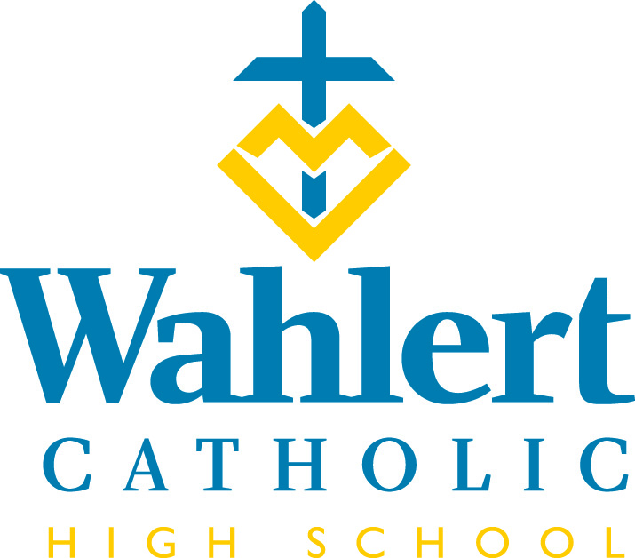
Fly-By for Dec. 1 – Jan. 5, 2017
This weekly FLY-BY strives to communicate the events and news of Wahlert Catholic in a somewhat timely manner.

We hope you had a pleasant Thanksgiving. We’re gearing up for Advent activities like Operation ELF in which various classes adopt a needy family from our parishes and help provide them with Christmas gifts and basic living items like toilet paper, tissues, laundry detergent, shampoo, etc. Many classes are collecting money to buy the gifts, so don’t be surprised if your student is looking for a way to earn a little extra money. The whole thing wraps up (literally) around Dec. 15 with delivery on Dec. 19.

Congratulations to Coach Lindsey Beaves and the girls’ volleyball team, which repeated as state champions. Members of the All-Tournament team included Jenna Gremmel and Krystal Tranel, who were members of last year’s all-tournament team, and Aliyah Carter, who was selected as captain of the all-tournament team.

Congratulations to the following football players who received post-season recognition:
3A District 4 All-Academic Football
(junior or senior with a cumulative GPA of 3.5 or higher)
Cameron Haugen, Will Hutchinson, Kelan Dickson, Joe Friend, Chris Ripley, Zach Kemp, Joey Callahan, Isaac Walsh, Alex Hingtgen, Jace Kunkel, Dino Onyeukwu, Eli Berthel, Spencer Goerdt, Blake Bradley, Matt Bandy

3A District 4 All-District Football
Brock Osthoff – 2nd team linebacker; Eli Berthel – 2nd team offensive line; Kelan Dickson – 2nd team running back; Will Hutchinson – 2nd team defensive back; Kolton Bartow – 1st team running back; Declan Duffy – 1st team defensive line; Blake Bradley – 1st team defensive line; Spencer Goerdt – 1st team offensive line; Zach Kemp – 1st team defensive back; Dino Onyeukwu – 1st team linebacker; Joe Friend – 1st team linebacker

3A District 4 Defense MVP
Blake Bradley

Iowa Newspaper Association All-State Football
Blake Bradley (2nd Team)
Spencer Goerdt (3rd Team)

Team Awards
Kelan Dickson - Jack Burgmeier 2nd Effort Award
Joe Friend - Special Teams MVP
Blake Bradley - Defense MVP
Kolton Bartow - Offense MVP
Zach Kemp - Team MVP

Good luck to Ms. Amanda Collins and the Dance Team, which is competing at the State Dance Competition yesterday and today.

IN THE WEEK AHEAD…
Next week’s schedule will be: O-E-O-E-O*. Friday, Dec. 8, we will be on a mass schedule.

The week of Dec. 11-15, the schedule will be: E-O-E-O-E

Friday, Dec. 1: Fruit delivery
Sunday, Dec. 3: Instrumental Music Concert @ 7 p.m.
Tuesday, Dec. 5: Winter Pep Rally
Wednesday, Dec. 6: 5th Grade Science Day
Friday, Dec. 8: Immaculate Conception Mass @ 10:05 a.m.
Saturday, Dec. 9: FCA Dodgeball Tournament from 4 to 7 p.m.
Sunday, Dec. 10: Choir Concert at the Cathedral @ 7:30 p.m.
Wednesday, Dec. 13: Meeting for trip to Spain in Mrs. Leonard’s room @ 6 p.m.
Thursday, Dec. 14- Sunday, Dec. 17: Kairos XII begins
Tuesday, Dec. 19: Operation ELF delivery
Thursday, Dec. 21: Advent Prayer Service @ 1:50 p.m.
Saturday, Dec. 23- Tuesday, Jan. 2: Christmas break
Wednesday, Jan. 3: Classes resume
Thursday, Jan. 4 – Sunday, Jan. 7: Kairos 13
Jan. 4-5: Benchmark Test in English classes
Friday, Jan. 5: Jam the Gym
OTHER THINGS YOU MAY WANT TO KNOW…
HOW SWEET IT IS!
The Teacher Appreciation group is asking for your help in donating sweet treats so that we can put together candy/cookies trays for the teachers for Christmas. We will be sending out an email through Genius Sign-up soon and would appreciate your generosity. If you have any questions, please contact Wendy Herrig at mwsamherrig@msn.com

TUTORING AVAILABLE
Does your student need tutoring in math, science or other areas? This link takes you to information about a tutor available in Dubuque: https://www.holyfamilydbq.org/ebulletin-board

MISSING CAMERA BAG
At the welcome home rally for the girls’ volleyball team, Ms. Gaul accidentally left her camera backpack behind. It is black with a bright yellow lanyard woven through the front. It had a camera charger, lens cap, and other camera accessories in it, but no camera (which was hanging around Ms. Gaul’s neck!) Unfortunately, the bag disappeared before Ms. Gaul returned to the gym, and she’s wondering if anyone picked it up. The yearbook staff would love to have the bag and its accessories back. Thanks.

ROBOTS IN ACTION
The Wahlert FTC Teams #7400 and #9025 will host a league meet Dec. 9th at the Mazzuchelli gym from 9 to 11 a.m. All are welcome to see the robots in action.
OUR LADY OF GUADALUPE CELEBRATION - ST. PATRICK CHURCH
The feast of Our Lady of Guadalupe (Patroness of the Americas) honors Mary's appearance to St. Juan Diego in Mexico. The bilingual celebration is Dec. 10th at St. Patrick’s and begins with a rosary at 10 a.m., a play about the apparitions at 10:30 a.m., Mass at 11 a.m. The celebration will end with a native dance honoring Mary and a potluck to follow in the St. Patrick basement. The event is free, family friendly and there are activities for the kids. It's a great opportunity to learn about this important cultural and spiritual event!

From the Holy Family Offices…
Holiday Fun for Pre-K and Kindergarteners
Polar Express Activity Night
Thursday, Dec. 7, from 6:30 - 7:30 p.m.
Resurrection Elementary School
Travel with us on the Polar Express. Pick up your train ticket from the conductor by entering through door #1. Enjoy stops on the train route including the Music Depot, the Elves’ Workshop, Santa’s Mail Room, the Glacier Gulch, the Photo Station and the Coal Yard. Don’t forget to visit Mrs. Claus’ kitchen before you leave!

Breakfast with St. Nick
Saturday, Dec. 2, from 9 - 10 a.m.
Holy Ghost Elementary School
Come join St. Nicholas for Christmas carols, a light breakfast and cookie decorating. RSVP is appreciated by Monday, Nov. 27, by calling Holy Ghost Elementary at (563) 556-1511.

Cookies and Carols
Saturday, Dec. 16, from 10 - 11:30 a.m.
St. Anthony Elementary School
Families are invited to join in the Christmas spirit with Christmas songs, finger plays, cookie decorating and hot chocolate. RSVP is encouraged by contacting avallee@holyfamilydbq.org or calling the school at (563) 556-2820.

This holiday season give the gift of a Catholic education
The Our Faith School Tuition Organization (STO) exists solely to make a Catholic education more affordable for every child. As an Iowa tax payer, you can help families with demonstrated financial need through a contribution to the STO. In return, you will receive an Iowa tax credit equal to 65% of your donation. The amount you contribute also qualifies as a charitable donation on a federal tax return. The available Iowa tax credits are filling up fast so visit www.OurFaithSto.org or call the Archdiocese of Dubuque at 800-876-3546 ext. 219 or 307 to learn more.

International Student Host Families Needed for Second Semester
Holy Family Catholic Schools has gained a reputation for excellence, and we routinely receive requests from international students looking to enroll at our schools. We currently have interest from an eighth-grade boy from China and an 11th-grade girl from Vietnam who wish to enroll for the spring 2018 semester. If you are interested in hosting one of these students as well as providing an expanded worldview for your own children, please contact Rebecca Mueller, director of enrollment, at 582-5456, ext. 289 or rmueller@holyfamilydbq.org.

Holy Family Hall of Honor – Make your Nominations
The Holy Family Catholic Schools Hall of Honor was established to recognize those who have made outstanding contributions to their work, their community, and to the Holy Family Catholic School community. We are proud to continue this tradition each year as we highlight the accomplishments and service of those who strive to make an impact professionally and personally. The four categories for nominations include:
- Professional Achievement Award
- Holy Family Catholic Schools Service Award
- Outstanding Service Award
- Rising Young Alumni Award
Learn more and summit your nomination today: https://holyfamilydbq.org/hallofhonor.

New Dress Code item: Women’s and Men’s Cardigan Sweaters
Cardigans are priced at $28.50 and available in sizes XS – 3XL (no youth sizes) in your choice of black, navy, royal or white.
Each sweater will be embroidered with a Holy Family crest of your choice. Crested cardigan sweaters are a newly-approved dress code item and may be worn during the school day over a dress code approved shirt.

Samples are now available to try on at the Holy Family Central Office located at 2005 Kane Street and are available for purchase online at the Holy Family eStore.

If you have any questions regarding the Holy Family eStore, please contact Tessa Petsche at tpetsche@holyfamilydbq.org or call 563-582-5456.
For Holy Family Catholic Schools news and events, find us on Facebook, Twitter, or visit www.holyfamilydbq.org.

UPCOMING EVENTS
Jan. 12: End of first semester
Jan. 13: Show Choir Home Show at 2 and 7 p.m.
Jan. 14: Interact Dance
Jan. 15: No classes
Jan. 16: Second semester begins
Jan. 19-21: Winter play
Jan. 19: Show Choir & Jazz Band Show for grades 4-8
For more information about these events, see the Wahlert Catholic website at http:// holyfamilydbq.org or contact the school at
(563) 583-9771.
This information was compiled by Sandy Gaul, publications’ adviser. Her email is
sgaul@holyfamilydbq.org

