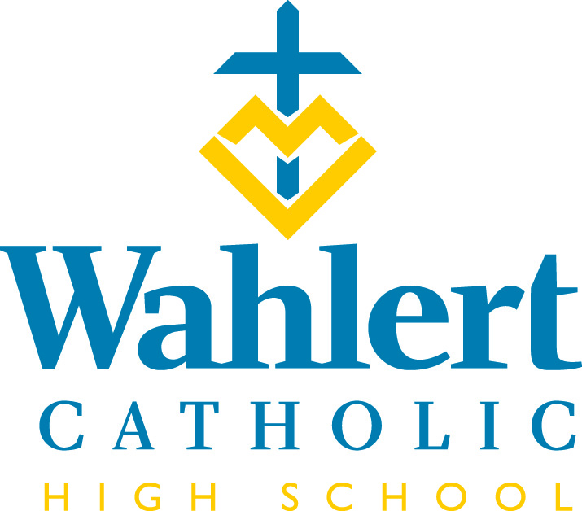
Fly-By for Feb. 9 – Feb. 23, 2018
This weekly FLY-BY strives to communicate the events and news of Wahlert Catholic in a somewhat timely manner.

Thanks, thanks to thee!
The Teacher Appreciation Group would like to thank parents for the meals they provided for teachers during Parent/Teacher Conferences. It was such a success! Thank you for donating money, sending delicious food/drinks, setting-up and cleaning-up afterwards. The teachers wholeheartedly appreciated it. Also, thank you to Kelly Mussehl for delivering delicious Godfather's Pizza to the staff lounge.
Shout out to our Science Quiz Bowl team who won two and lost two at the state competition in Ames: Sophia Shubatt, Joe Patrick, Ann Hermann, Jayne Munshower and Gabe Wigginton.
Congratulations to Jacob Nuti, Rebecca Meissen, Isabel Shubatt, and Elizabeth Fitzsimmons, who were chosen to perform/present their Individual Events at the International Thespian Festival this summer in Lincoln, Nebraska. Jacob will perform his solo musical theatre selection, Isabel and Elizabeth will present their short film, and Rebecca will present her scenic design.
Freshman Catherine Curtis placed 1st (winning a Gold Key) in the Scholastic Arts and Writing National Competition in Iowa. Her short story, "There is No Window in My Room," will be forwarded to compete at the next level: Regionals. She has been invited to accept her award in March at a Celebration/Reception held in The Memorial Union at the University of Iowa. Congratulations and good luck, Catherine.
Congratulations to the students who received their Confirmation at St. Columbkille during the 10 a.m. Mass on Feb. 4, 2018. This is a joyous witness to our Catholic faith.
Have you purchased a 2017-2018 yearbook for your student yet? As of today, only 280 yearbooks have been ordered. Since we usually sell close to 400, that number seems off. If you did not check the yearbook box on the One Check form, then you probably haven’t ordered a book. Students have also been sent a list via their email of who has purchased a book. Cost is $55 and check should be made payable to “Wahlert Yearbook.” Send them to the attention of Ms. Sandra Gaul, yearbook adviser. You can also email Ms. Gaul at sgaul@holyfamilydbq.org to check if you have ordered a book.

NOT THE FLU, BUT A LIFETIME HEALTH HAZARD
While the number of teens smoking cigarettes has significantly declined, vaping (inhaling and exhaling the vapor produced by an electronic cigarette) appears to be growing in popularity, a trend that has raised concern. Research indicates that there may be significant health effects. Vaping can expose your teen to nicotine, toxic substances, and may result in impaired wound healing. Please talk with your son/daughter about the dangers of vaping and e-cigarettes.

IN THE WEEK AHEAD…
Next week’s schedule will be: O-E-O. There are no classes on Thursday, Feb. 15, and Friday, Feb. 16. Thursday is an in-service day for teachers and there are parent-teacher conferences from 11 a.m. to 1 p.m.

The week of Feb. 19-23, the schedule will be: E-O-E-O-E

Sunday, Feb. 11: Rock the Rafters. The Wahlert Dance Team’s Rock the Rafters Dance Showcase is at 2:30 p.m. in the Wahlert Gym. Come see your own Wahlert Dance Team perform their state routines, as well as their partner dance. The show will also include performances from Dubuque Dance, Studio 5678, Senior Color Guard, and your Rock the Rafters’ Dance Campers. Doors will open for the show at 2 p.m. and admission is $5; children under five are free. We hope to see you there!
Feb. 12: 9th Grade Course Selection Night from 6:30 to 8 p.m.
Feb. 12: First day of practice for men’s and women’s track.
Feb. 13: Blood drive from 8:30 a.m. – 12:30 p.m.
Feb. 14: Ash Wednesday Mass at 10:05 a.m.
Feb. 15: Parent-Teacher Conferences from 11 a.m. to 1 p.m.
Feb. 16: No school
Feb. 16: Deadline for parents to place an ad for their senior in the yearbook. You should have received information in the mail in the fourth week of January. If you did not, please contact Ms. Gaul at sgaul@holyfamily.dbq.pvt.k12.ia.us.
Feb. 17: 9th Grade Course Selection Day from 9 to 10:30 a.m.
Feb. 23: Winter dance
OTHER THINGS YOU MAY WANT TO KNOW…
ADVICE FROM THE NURSE
It is that time of the year again, Influenza A and B and colds are back. Signs and symptoms of influenza include:
-fever/chills
-cough
-sore throat
-runny or stuffy nose
-muscle or body aches
-headaches
-fatique
-some people may have vomiting and diarrhea
Symptoms of influenza can range from mild to severe and often take anywhere from 1 to 2 weeks to run their course. Incubation period of influenza infections are 1 to 4 days.
Treatment for influenza includes making sure the individual continues to drink plenty of fluids, get plenty of rest, and treatment of symptoms. If illness persists or gets worse, it is advised you seek medical treatment from your doctor.
Students may return to school once they are fever free for 24 hours without the aid of fever reducing medication.
When calling your student in ill please inform secretary if the student has respiratory or stomach symptoms.

If you have any questions you may contact the nurse.

TEC (TEENS ENCOUNTER CHRIST)
There are two TEC's remaining for seniors this year: March 3-5 at Dyersville Beckman and April 7-9 in Calmar. Please encourage seniors that you know to sign up. www.DbqArch.org/TEC is the place to sign up. Wahlert faculty will drive the seniors there and pick them up, too. If you have any questions ask Jim Kuhl: jkuhl@holyfamilydbq.org

SENIOR CLASS PICTURE
For the past five years the number of students purchasing a senior class picture has dramatically declined. Last year only 15 students purchased the picture. Due these low numbers, a senior class picture will not be taken this year.

SOPHOMORES MAY NOW HOLD THEIR PLACE FOR THE 2018 TETON SCIENCE TRIP:
The 2018 Teton Science School Trip will be Nov. 11-17. Registration materials are available from Mrs. Korrin Schriver. Current sophomores now have the opportunity to register without the possibility of being "bumped" by a current junior. Both current juniors and sophomores can register by filling out the form attached to the information packet and submitting that registration form, along with their $450 deposit, to Mrs. Schriver. Please contact her with any questions (kschriver@holyfamilydbq.org).

PARENT ADS FOR SENIORS
You should have received a mailing in the last few weeks indicating how you could place an ad recognizing your senior in the yearbook. The deadline for payment and ad information is Feb. 16. If you have questions or did not receive a mailing, email Ms. Gaul at sgaul@holyfamilydbq.org.

DRIVER EDUCATION CLASS
Clem Walleser of Patience & Quality Driving Academy will be offering a driver education class beginning the second week of February and finishing by the end of March, depending on the weather. There are still a few spaces remaining. Mr. Walleser can be reached at (563) 583-5197 or (563) 543-7171. If no one answers, please leave a message and he will return your call.

CHINESE TUTORS
The Multicultural Family Center is beginning a new tutoring program in February. The program, for 8th through 12th grade students, offers tutoring in math, science or Mandarin Chinese. This drop-in style tutoring program will be offered Monday-Thursday from 3:30 p.m. to 7:30 p.m. The program will start Feb. 5th and continue through May 3rd, 2018. Additional support may be available after May 3rd if necessary.

TUTORING AVAILABLE
Does your student need tutoring in math, science or other areas? This link takes you to information about a tutor available in Dubuque: https://www.holyfamilydbq.org/ebulletin-board

From the Holy Family Offices…
LAST CHANCE to get in on EVERY DRAWING – Buy your Quick Cash Raffle Tickets now!
This year’s Circle of Celebration raffle features nine drawings beginning with the first drawing on Monday, Feb. 12. Each ticket makes you eligible for every drawing, so don’t miss the chance to be included in all! Contact Christine McAllister at cmcallister@holyfamilydbq.org or 563-582-5456 to purchase tickets before 2 p.m. on Monday, Feb. 12, or visit holyfamilydbq.org/raffle. Tickets may also be returned to the Holy Family Central office at 2005 Kane St. or to your child’s school.

An aid for your Lenten journey
Holy Family’s Religion and Mission Committee again offers a Lenten activity/reflection booklet to guide your family’s journey through the Lenten season. If you would like one of these booklets, please contact the secretary at your child’s school, and she will send one home with your child.

Tuition Assistance Application Now Open
The tuition assistance application is now open. For more information, or to fill out an application, visit: https://holyfamilydbq.org/admissions/apply-for-tuition-assistance.

Tuition Assistance Help Nights
Two help nights are scheduled for families who would like help with the FACTS tuition assistance application. A help sessions will take place on Tuesday, Feb. 20, from 6 to 7:30 p.m. (a Spanish-speaking volunteer will be available) in the Holy Family Catholic Schools Central Office at 2005 Kane St., Dubuque. If you need assistance and are unable to attend these sessions, please contact Katie Tracy, Tuition Coordinator, at 563-582-5456 or ktracy@holyfamilydbq.org to make an appointment. More information on FACTS tuition assistance can be found at holyfamilydbq.org.

Thanks for your support on Eagles Give Day!
Holy Family’s second-annual Eagles Give Day was a huge success, and it couldn’t have been done without your support! In a period of 24-hours, our families, friends and alumni made 363 contributions, which enabled us to leverage an additional $10,000 in challenge gifts and two $1,500 matching gifts for a total of $33,422. We are truly in awe of the generosity you have shown. Thank you for helping make what we do possible!

Employment Opening
St. Columbkille Elementary School is seeking a temporary custodian from March 1 through approximately May 1, 2018. Responsibilities include general janitorial tasks such as cleaning restrooms, vacuuming/mopping and general dusting. Compensation is $11.50/hour. Hours are Monday-Friday, 6:30 a.m.-2:30 p.m. Please send resume to Jeff Rusch at jrusch@holyfamilydbq.org or call 563-213-0188.
For Holy Family Catholic Schools news and events, find us on Facebook, Twitter, or visit www.holyfamilydbq.org.

UPCOMING EVENTS
March 1: Band & choir concert @ 7 p.m.
March 12: Practice for women’s golf, men’s & women’s tennis and men’s soccer begins.
March 14: Grandparents’ mass
March 18: Golden Finale for show choirs
March 19: First day of practice for women’s soccer.
March 19: ZAPPS – ACT prep course
March 20: ZAPPS
March 20: ICAN College and Career Planning. ICAN Financial Planning Night
March 21: Reconciliation
March 22: Reconciliation
March 26-30: Spring Break
April 5-8: Kairos 14
April 7: Circle of Celebration
April 9: NHS Induction ceremony
April 14: ACT at Wahlert
April 20-22: Musical
For more information about these events, see the Wahlert Catholic website at http:// holyfamilydbq.org or contact the school at
(563) 583-9771.
This information was compiled by Sandy Gaul, publications’ adviser. Her email is
sgaul@holyfamilydbq.org

