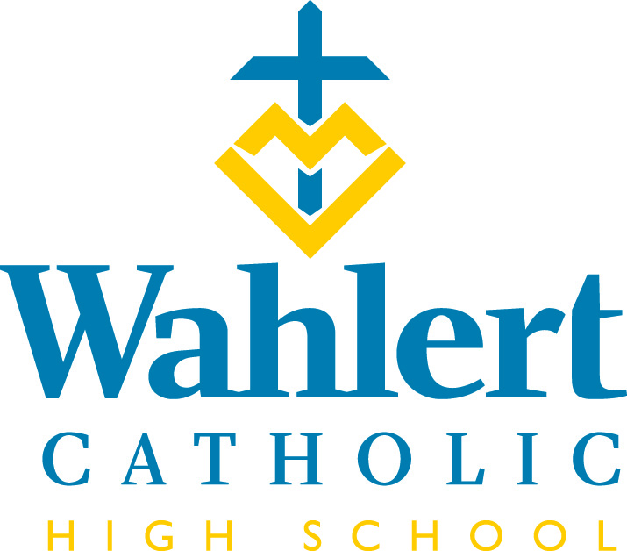
Fly-By for Nov. 10 – Dec. 1 , 2017
This weekly FLY-BY strives to communicate the events and news of Wahlert Catholic in a somewhat timely manner.

Congratulations to the girls’ volleyball team who is competing at the state tournament this week.

Congratulations to Coach Cindy Wagner and the girls’ cross country team who are state champions in 3A. Members of the team are Grace Herber, Gabby Moran, Emma Earles, Kaylee Osterberger, Holly Hohmann, Emma Wachter, Aunna Huseman, Gracie Long, Kylie Cox , Olivia Blosch and Managers Holli Hammerand and Olivia King.

Congratulations to Cara Sullivan who competed at the state NATS competition for singers, and placed third in the state in High School Women (Classical selections).
Congratulations to the women’s swimming and diving team, which placed 10th overall at the state meet last weekend. Since there are no classes in swimming and diving, that means they are one of the top 10 teams in Iowa! The following young women competed for Wahlert: Tori Michels, Natalia Verastegui, Alaina Schmidt, Karlie Welbes, Hayley Welbes, Elly Kalb, Abbie Montag, Maria Kircher, Brielle Osthoff, Anna Kalb, and Zoe Heiar.

Congratulations to the Wahlert Dance Team's soloists Joey Rauch and Sophie Hefel for their performances at the State Solo Dance Competition Nov. 4! Both scored division 1 ratings on their solos, and Rauch took 3rd place and Hefel took 13th place out of the 73 competitors at the State Solo Competition!

The Wahlert Dance Team will be performing their State Lyrical routine at the Girls JV Basketball Game on Tuesday, Nov. 21st and their State Jazz routine at the Girls Varsity Game on Tuesday, Nov. 21st. Come out and see both our Dance Team and our girls’ basketball teams!

The Wahlert Dance Team will be competing at the State Dance Competition on Thursday, Nov. 30th and Friday, Dec. 1st. Good luck at State!

Nov. 7th, eight students represented Wahlert Catholic at the JA Titan Business Simulation contest at NICC in Peosta. The competition was part of the local tri-state qualifying round. One team consisted of seniors Sam Gruhl, Luke Hilby, Collin Link and Joe Patrick.
Another team was made up of senior Alex Hingtgen and juniors Matt Becker, Jack Doyle and David Hughes. Each team finished second in their division of six teams. While neither team advanced to the regional round, these young men learned what goes into making a business successful and how to compete against other businesses. These students also learned valuable soft skills such as teamwork and problem solving that employers are looking for when hiring.
A special thank you to our community partner, Peter Fricano, for helping these young men prepare for this competition. Mr. Fricano is parent of two Wahlert Catholic graduates.

Congratulations to Mr. Tim Berning, and the girls’ track and field staff on earning coach of the year honors for the 2017 track and field season. The coaches will be honored at a Hall of Fame Banquet in Ames.
IN THE WEEK AHEAD…
Next week’s schedule will be: O-E-O-E-O.

The week of Nov. 20-21, the schedule will be: E-O. Thanksgiving break will be from Nov. 22 to 24.

The week of Nov. 27-Dec. 1, the schedule will be: E-O-E-O-E

Saturday, Nov. 11-13: TEC at Wahlert

Sunday, Nov. 12-18: Teton Science School trip

Monday, Nov. 13: First day of practice for men’s basketball and wrestling

Wednesday, Nov. 15: Fruit Sale orders due
Sunday, Nov. 19: Renovation Open House, 1-4 p.m.

Tuesday, Nov. 21: Thanksgiving Prayer Service during seminar

Wednesday, Nov. 22-Nov. 24: No school. Thanksgiving break.

Thursday, Nov. 23: Turkey Trot at 9 a.m. Registration from 7:30 to 8:45 a.m. the day of the race. See below for more information.

Wednesday, Nov. 29: Reconciliation

Thursday, Nov. 30: Reconciliation

Nov. 30-Dec. 1: State Dance competition

Friday, Dec. 1: Fruit delivery

OTHER THINGS YOU MAY WANT TO KNOW…
PRAYERS REQUESTED
TEC (Teens Encounter Christ) is at Wahlert Catholic this weekend. Please pray for everyone making TEC this weekend. The following seniors are candidates on the retreat. Grace Herber, Gracie Stran, Anna Herrig, Audra McMahon, Zach Kemp, Owen Borelli, and Ali Forbes.

ORANGES & APPLES & PEARS – AND MUSIC, TOO!
Wahlert fruit sales are currently underway to support our students who are involved in music! If you would like to order fruit and haven't been approached by a student yet, you may contact Aaron Behnke at abehnke@holyfamilydbq.org to order fruit. Orders are due by Nov. 15. Thank you!
ROBOTS IN ACTION
The Wahlert FTC Teams #7400 and #9025 will compete Saturday, Nov. 11, for their first league meet of the season at Bellevue. The teams will host a league meet Dec. 9th at the Mazzuchelli gym from 9 to 11 a.m. All are welcome to see the robots in action.
YEARBOOK SENIOR PORTRAITS
Senior portraits for the yearbook were due Friday, Nov. 3. Many of you sent in your pictures. Thank you! If you missed the deadline, please try to send the photo in as soon as possible. Pictures (exchange size) can be sent/given to Ms. Gaul in room 231 OR a JPEG can be sent electronically to Ms. Gaul's email: sgaul@holyfamilydbq.org
JPEG's need to be at least 300 dpi. Not sure what that is? Then submit a 5 x 7 version of the picture.
Portraits should be vertically oriented, head and shoulders shots. They should not have props in them and should have a non-distracting background. If you have questions, email Ms. Gaul.

EXPLORE SOME CAREERS
The Exploring program offers great opportunities for students to check out careers that they’re interested in. For more information and to get involved, go to exploringdubuque.org/

NCYC VIEWING PARTIES
St. Joseph the Worker parish will host live viewing parties of the keynote speakers at NCYC on Nov. 16-18 from 6:45 to 9 p.m. at St. Joseph the Worker Church. All are welcome. There will be snacks, live music, prayer and a freewill offering benefiting Catholic youth ministry in Dubuque.

From the Holy Family Offices…
Mazzuchelli Catholic Middle School Open House
Thursday, Nov. 16, 5:30 - 7:00 p.m.
Families of current middle school and fifth-grade students are invited to tour Mazzuchelli Catholic Middle School and explore our innovative programming. Learn more about EDGE, Gateway to Technology and our extracurricular activities that encourage goal-setting, teamwork and leadership. Register online at holyfamilydbq.org/mcms.

Join Us to Tour the Renovations at Wahlert Catholic High School
Sunday, Nov. 19, 2017, 1 - 4 p.m.
The renovations are complete and we are excited to showcase the new Wahlert Catholic campus!
Community members are invited to join us for an open house and a self-guided tour of the renovations. Students and staff will be present throughout the building to answer your questions and show you the highlights. Everyone is welcome and no registration is necessary.
If you have any questions, please call the Advancement Office at 563-582-5456 ext. 255.

Turkey Trot Registration is Now Open!
Sign up today to participate in our 45th Annual Thanksgiving Day Turkey Trot. The event will be held on Thursday, Nov. 23, 2017, at Wahlert Catholic High School. The race starts at 9 a.m. and attendees have the option to choose from a two-and-a-half-mile or five-mile course. Registration is $10 and long-sleeved t-shirts are available for purchase ($20). A certificate for a frozen turkey will be awarded to the first-place finisher in each age division.

Visit https://holyfamilydbq.org/wchs/turkey-trot for more information and to register online. Registration will also be held in the Wahlert Catholic High School gym from 7 – 8 p.m. on Wednesday, Nov. 22, and 7:30 – 8:45 a.m. Thursday, Nov. 23.

Advent Family Night
We invite you to join us for Advent Family Night on Thursday, Nov. 30, at 6 p.m. at St. Anthony Church. Fr. John Haugen, pastor of the churches in the Emmaus Pastorate of the Archdiocese, will speak about “Traditions” and there will be activities for all ages. An optional pizza dinner will be available beginning at 5:30 p.m. in O’Malley Hall. Cost for the meal is $4 for middle school students through adults and $2 for children age 4-12. Babysitting is available for children under three. RSVP online or call 563-582-5456 to register today.

What’s this STO all about?
It’s about supporting Catholic education in the Archdiocese of Dubuque and making the most out of your charitable contribution. If you file an Iowa income tax return, your contributions to the Our Faith School Tuition Organization (STO) qualify for a 65% tax credit. That means for every $1000 you donate, you receive an Iowa income tax credit $650, which reduces your Iowa tax liability by $650. Thus, a $1000 contribution reduces your Iowa tax liability by a whopping $650 AND the entire amount of your gift qualifies for federal deductibility. Visit www.OurFaithSto.org or call 800-876-3546 ext. 219 or 307 to learn more.

New Dress Code item: Women’s and Men’s Cardigan Sweaters
Cardigans are priced at $28.50 and available in sizes XS – 3XL (no youth sizes) in your choice of black, navy, royal or white.
Each sweater will be embroidered with a Holy Family crest of your choice. Crested cardigan sweaters are a newly-approved dress code item and may be worn during the school day over a dress code approved shirt.

Samples are now available to try on at the Holy Family Central Office located at 2005 Kane Street and are available for purchase online at the Holy Family eStore.

If you have any questions regarding the Holy Family eStore, please contact Tessa Petsche at tpetsche@holyfamilydbq.org or call 563-582-5456.

Holy Family Hall of Honor – Make your Nominations
The Holy Family Catholic Schools Hall of Honor was established to recognize those who have made outstanding contributions to their work, their community, and to the Holy Family Catholic School community. We are proud to continue this tradition each year as we highlight the accomplishments and service of those who strive to make an impact professionally and personally. The four categories for nominations include:
- Professional Achievement Award
- Holy Family Catholic Schools Service Award
- Outstanding Service Award
- Rising Young Alumni Award
Learn more and summit your nomination today: https://holyfamilydbq.org/hallofhonor.
For Holy Family Catholic Schools news and events, find us on Facebook, Twitter, or visit www.holyfamilydbq.org.

UPCOMING EVENTS
Dec. 3: Instrumental Music Concert @ 7 p.m.
Dec. 5: Winter Pep Rally
Dec. 6: 5th Grade Science Day
Dec. 8: Immaculate Conception Mass @ 10:05 a.m.
Dec. 10: Choir Concert
Dec. 14-17: Kairos XII
Dec. 19: Operation ELF delivery
Dec. 21: Advent Prayer Service @ 1:50 p.m.
Dec. 23-Jan. 2: Christmas break
Jan. 3: Classes resume
For more information about these events, see the Wahlert Catholic website at http:// holyfamilydbq.org or contact the school at
(563) 583-9771.
This information was compiled by Sandy Gaul, publications’ adviser. Her email is
sgaul@holyfamilydbq.org
Welcome to the eBulletinBoard! To communicate opportunities for enriching youth and family activities in our community while also adhering to our system's green vision, Holy Family Catholic Schools uses the online eBulletinBoard. Below is a list of new postings for the month. PDF flyers can be accessed anytime at http://www.holyfamilydbq.org/ebulletin-board.

Holy Family Flyers:
- Does your son or daughter have too much energy? The Little Eagles Wrestling Club can burn it off! Practices began Oct. 17. They are every Tuesday and Thursday through February. Cost is $60 and open to all K-8 students.
Community Flyers:
- Adventure Lab – Don’t let your students miss this opportunity! Creative Adventure Lab is hosting Adventure Days during non-school days. Your students will have the opportunity to participate in 2 special adventures each day and create their own adventures within our laboratories. Adventure Days (8:30-3:30pm) October 19th - Robotics and Watercolors December 29th - Lego Challenges and Pottery February 15th - Comic books and Electric Currents March 30th - Acrylic Painting and Drones
- Dubuque Symphony Orchestra Family Holiday Concert – Saturday, December 2 at 1:00 p.m. Five Flags Theater Kid-friendly holiday program with guest appearances by vocalist Jillian Slade, Dubuque Chorale Children’s Choir and members of the Heartland Ballet. Free photos with Santa following the concert! www.DubuqueSymphony.org
- Dubuque Symphony Orchestra Spring Family Concert – Saturday, March 24 at 1:00 p.m. Five Flags Theater Romeo and Juliet inspired pieces and memorable movie themes from Raiders of the Lost Ark, Lord of the Rings, Jurassic Park, Beauty and the Beast and Star Wars. Come in costume for this one hour concert followed by post-concert activities! www.DubuqueSymphony.org
- Animal Welfare Friends Shoe Drive Fundraiser – Donate shoes to raise funds that will help care for animals until they find their forever homes. Shoe Drive runs Sep. 5 – Nov. 5.
- 2017 Loras College Duhawk Dunkers – Saturdays, 8:30 - 10:00 a.m. Oct. 21, 28, Nov. 5 and 12. Skill development for boys and girls age 4-14
- UD Heritage Center Family Series – This coming year, the University of Dubuque Heritage Center will have four great Family Series performances, including “The Cat in the Hat,” “Treasure Island,” “Guess How Much I Love You & I Love My Little Storybook,” and “Moon Mouse: A Space Odyssey.”

