William T. and Deborah L. Coakley Scholarship
Scholarship Amount: $1,250 per academic year (up to 4 years)
Scholarship Deadline: Friday, April 28, 2023
If you are interested in applying for this scholarship, please meet with Mrs. Debbie Bandy in the Wahlert Counseling Office for additional information,
as well as the scholarship application.

The recipient of this scholarship shall be designated by the Office of Financial Planning at Loras College based on normal admission and financial aid policies and the following criteria:
Exclusively to students from Wahlert Catholic High School in Dubuque, Iowa, who are involved in extra-curricular activities with consideration given to students with demonstrated financial need.
- Examples of extra-curricular activities include, but are not limited to:
  - Orchestra and Wind Ensemble (band)
  - Vocal and Theatre Arts
  - Mock Trail
  - Moot Court
  - Plans to become a Seminarian
- The scholarship may be renewed each school year to the named recipient for a maximum of 4 years (includes first year receipt of scholarship) or graduation from Loras is achieved.

Please turn in completed, typed application to Mrs. Bandy in the Counseling Office by Friday, April 28th.

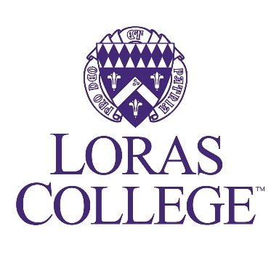

Questionnaire for William and Deborah Coakley Scholarship
- Please type all answers in complete sentences. No handwritten answers.
- Spell out all acronyms and explain the purpose of the organization or club.
  - For example: FCA (Fellow Christian Athletes) for athletes to enhance their faith as a group.
- Final candidates will be offered an interview the week of May 1st.

Name: ___________________________ Date: ___________________________

Please list extra-curricular activities that you are involved in at Wahlert Catholic High School.
_________________________________________________________________________________________________________________________________________________________________________________________________________
Please share why you were involved in these extra-curricular activities. What did you learn from these activities?
_______________________________________________________________________________________________________________________________________________________________________________________________________________________________________________________________________________________________________________________________________________
What extra-curricular activities do you plan to continue at Loras, and why?
_______________________________________________________________________________________________________________________________________________________________________________________________________________________________________________________________________________________________________________________________________________

What are your goals after you graduate from Loras?
_______________________________________________________________________________________________________________________________________________________________________________________________________________________________________________________________________________________________________________________________________________________________________________________________________________________________________________________________________________________________________________________________________________________________________________________________________________________________________________________________________________________________________________________________________________________________________________________________________________________________________________________________________________________________________
Please provide anything else about yourself that a person should consider when making the decision as to who will receive the William and Deborah Coakley Scholarship.
________________________________________________________________________________________________________________________________________________________________________________________________________________________________________________________________________________________________________________________________________________________________________________________________________________________________________________________________________________________________________________________________________________________________________________________________________________________________________________________________________________________________________________________________________________________________________________________________________________________________________________________________________________________________________________________________________________________________________________________________________________________________________________________________________________________________________________

