CLASS OF 1970

FOUR MOUNDS TOUR

SUNDAY OCTOBER 12, 1:00 pm

(weather permitting)

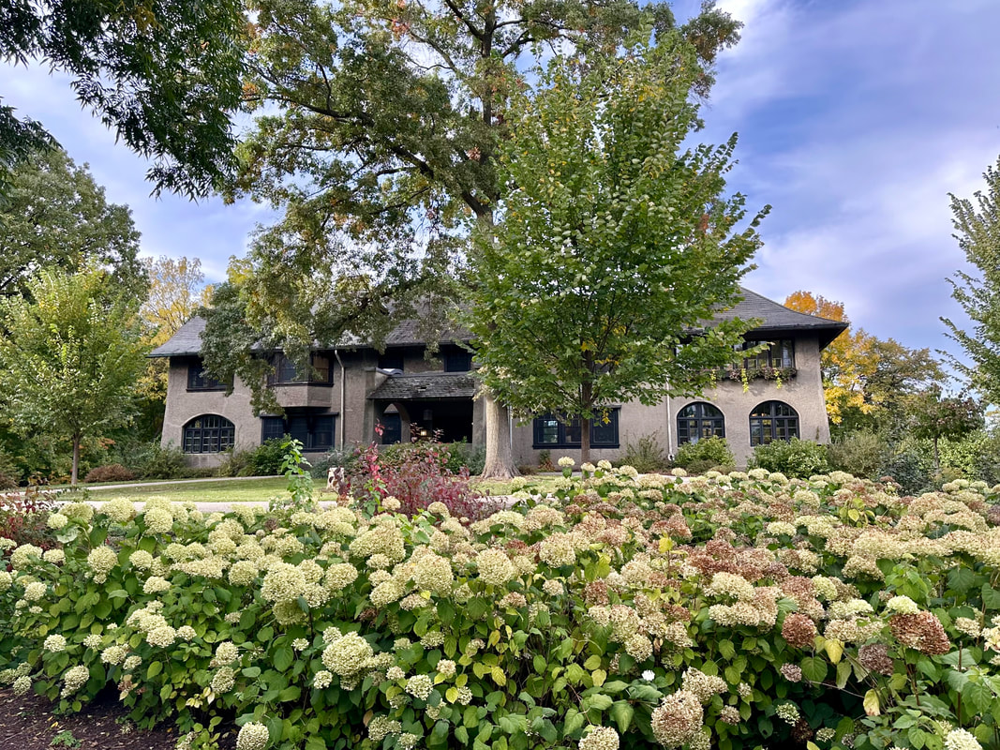

|  |  |
| --- | --- |
| Number of visitors = | Number of automobiles = |

